Medium VBA Homework solution image

Sheet 1: Year 2016

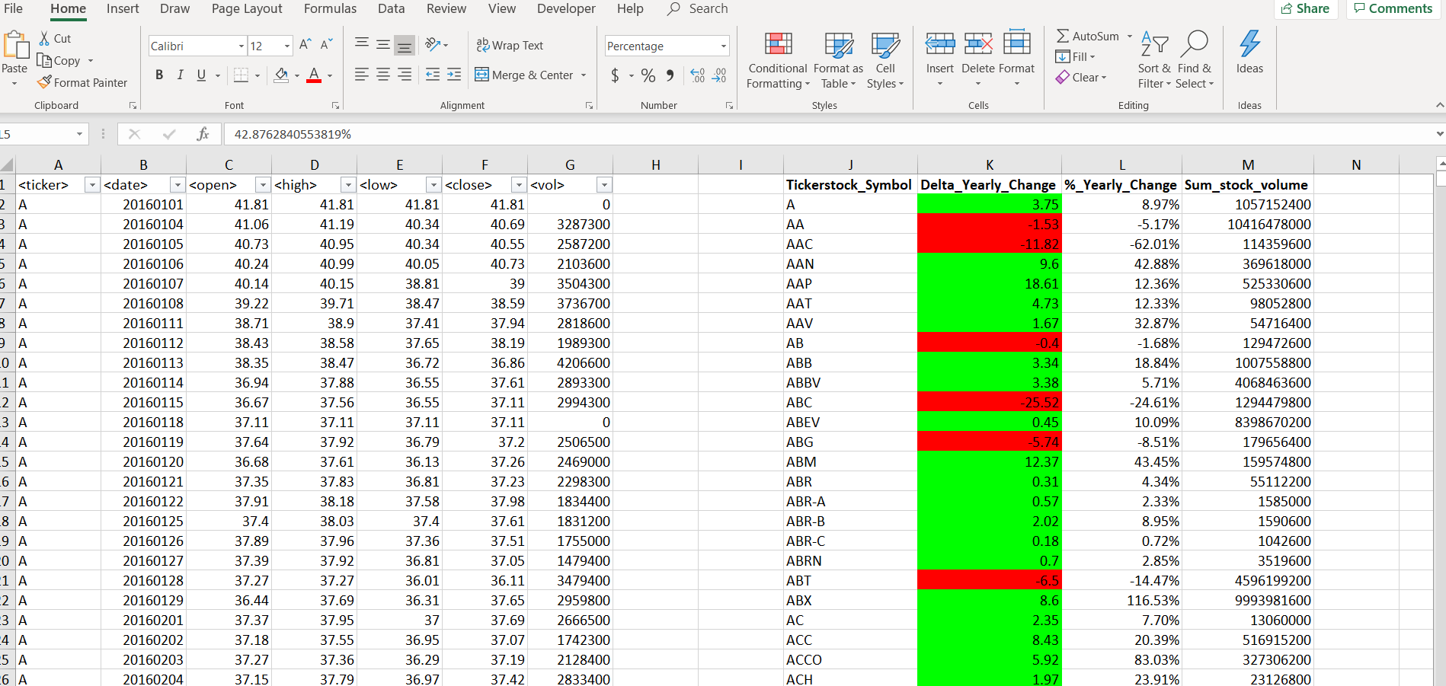

Sheet 2, Year 2015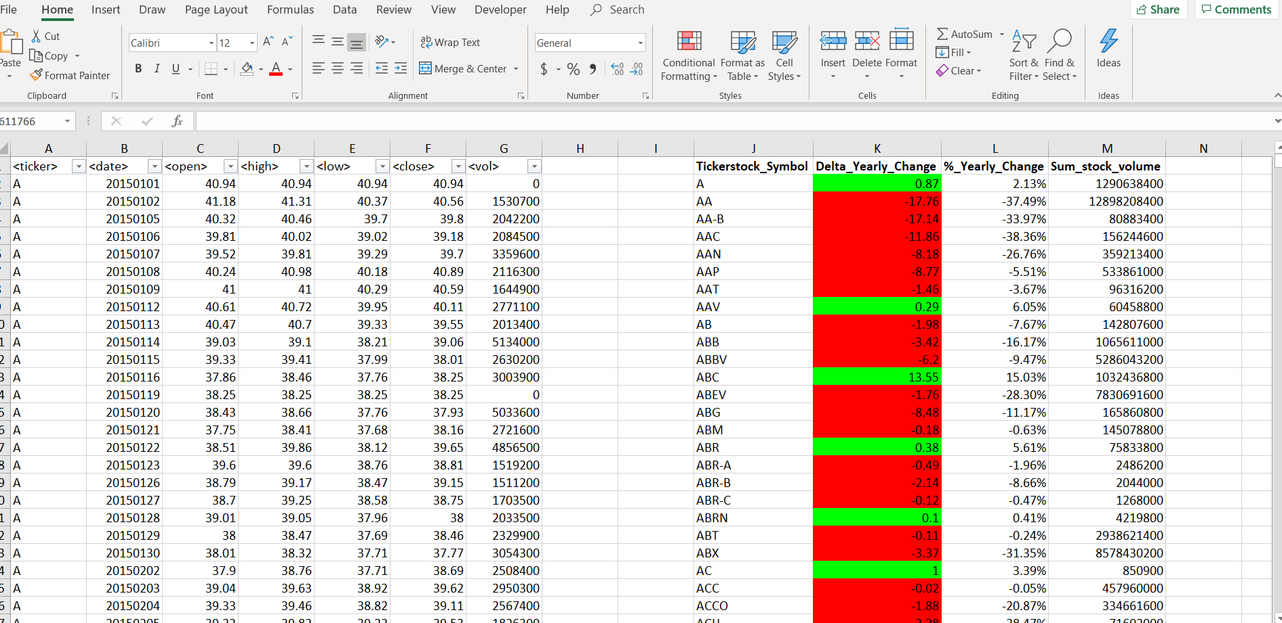

Sheet 3, Year 2014

